My Product Design Process in Action
Undefeated Art Gallery
Designing an emotional, story-driven art discovery experience

Step 1: Introduction
Project: Undefeated Art Gallery
Role: Product Designer
This project reflects how I approach design, starting from understanding people, to defining meaningful experiences, to building products that drive both emotion and outcomes.

Step 2: Where I Start, The Problem
I do not start with interfaces. I start with gaps.
Most art platforms prioritize browsing and transactions, but ignore meaning.
What this creates:
- Users see art but don’t understand it
- Low emotional engagement
- Hesitation to purchase

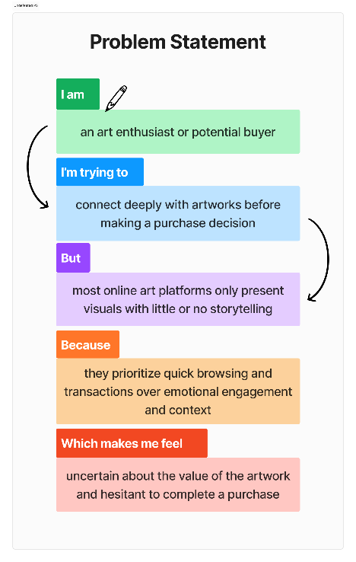
Step 3: Framing the Right Question
Before jumping into solutions, I define the problem clearly.
How might we help users feel something before they buy something?
This question guided every design decision that followed.

Step 4: Understanding Users Deeply
I design based on people, not assumptions.
User Groups
The Meaning Seeker
Wants depth, context, and emotional connection
The Aesthetic Buyer
Drawn to visuals but needs reassurance
Key Insight
Users don’t lack access to art, they lack connection to it.

Step 5: Defining the Experience Vision
Before structure, I define the experience.
I asked:
What should this product feel like?
Experience Direction:
- Immersive
- Emotional
- Intentional
This led to a shift from an e-commerce platform to a
Story First Art Discovery Experience

Step 6: Structuring the Experience
I translate ideas into structure through Information Architecture.
Core Flow
- Discover
- Artwork
- Story
- Artist
- Purchase
Key Decision
The story comes before the transaction, shaping how users engage.

Step 7: Designing the User Journey
I map how users move through the product.
Before:
Browse → View → Exit
After:
Discover → Read → Connect → Trust → Purchase
Design is not just flow, it is how the flow makes users feel.

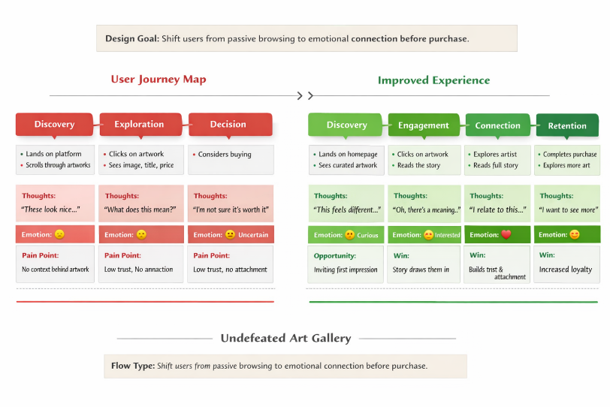

Step 8: Creating User Flows
I break the journey into actionable steps.
- User lands on homepage
- Explores curated artwork
- Selects a piece
- Engages with the story
- Understands the artist
- Makes a purchase decision
Each step is intentional, reducing friction and increasing connection.

Step 9: Wireframing, Thinking Before Visuals
At this stage, I focus on clarity, not aesthetics.
Key Focus Areas
- Content hierarchy, art to story to action
- Minimal distractions
- Guided storytelling
Core Question:
Is the design guiding emotion, or just enabling scrolling?

Step 10: Designing the Interface
I translate structure into visual experience.
Design Principles
- Art comes first
- Interface supports, not competes
- Simplicity enhances engagement
Execution
- Neutral color palette
- Elegant typography
- Spacious layouts
The goal was to create space for users to pause and connect.

Step 11: Building Key Features
Story First Artwork Page
Story is the entry point, not an afterthought
Artist Narrative Section
Builds trust and context
Guided Discovery
Helps users find art aligned with their interests
Every feature was designed to support emotional engagement.

Step 12: Applying Product Thinking
I design beyond usability, I design for impact.
User Value
- Stronger emotional connection
- Better understanding of art
- More confident decisions
Business Value
- Increased engagement time
- Higher conversion potential
Scalability
- Story framework reusable across the platform

Step 13: Defining Success Metrics
I measure outcomes, not just outputs.
- Time spent on artwork pages
- Story engagement rate
- Conversion after interaction
- User retention
These metrics validate both user experience and product success.

Step 14: Iteration and Refinement
I refine based on clarity and usability.
- Simplified navigation for smoother flow
- Improved visibility of storytelling elements
- Balanced emotion with action
Iteration ensures the experience feels effortless.

Step 15: My Design Philosophy
This project reflects how I approach product design:
- I start with understanding people and problems
- I design for emotion and usability
- I align decisions with business and user impact

Step 16: Closing
Undefeated Art Gallery is more than a platform.
It is a demonstration of my process,
where design moves from insight to experience to impact.
Because when users connect,
they don’t just browse, they decide with intention.

